

|  |
| --- |
| **Project Dashboard**  **Technical Design Document**  **Template Version 0.03 - Date Issued: July 5, 2016** |

# **1 - REVISION HISTORY**

|  |  |  |  |
| --- | --- | --- | --- |
| **Revision Number** | **Revision Date** | **Summary of Changes** | **Author** |
| 0.01 | 12/8/2016 | Document Created | Mayank Singla |
|  |  |  |  |
|  |  |  |  |
|  |  |  |  |
|  |  |  |  |

# **2 - TABLE OF CONTENTS**

1 - REVISION HISTORY

2 - TABLE OF CONTENTS

3 - PROJECT INFORMATION

3.1 PROJECT SUCCESS CRITERIA

3.2 ENTITY RELATIONSHIP DIAGRAM

3.3 HIGH LEVEL SYSTEM PROCESS FLOW

4 - NEW FUNCTIONALITY

4.1 PROCESS AUTOMATION

4.2 APPLICATION AND USER INTERFACE DESIGN

4.3 CONFIGURATION DETAILS

4.4 DATA SHARING MODEL

4.5 CUSTOM DEVELOPMENT DETAILS

4.6 SYSTEM INTEGRATION/INTERFACE

4.7 DATA MANAGEMENT

4.8 SELF-ASSESSMENT

5 - CONSIDERATIONS

# **3 - PROJECT INFORMATION**

|  |  |
| --- | --- |
| **Project Title:** | Project Dashboard |
| **Executive Sponsor:** |  |
| **Application Owner:** |  |
| **Business Project Manager:** |  |
| **OCIO Assigned Business Analyst:** |  |
| **Business Lines/Groups Impacted:** |  |
| **Subject Matter Expert Resources:** |  |

|  |
| --- |
| **3.1 PROJECT SUCCESS CRITERIA** |

*State the project goal and the contributors to that goal in an indented enumerated or bulleted list(s). This will relate to section 2.3 (Business Need and Success Criteria) in the Project Detail.*

***What is the Problem? Describe the specific business problem this project is intended to solve, or the business process that would be improved.***

The “team” currently tracks X number of Projects in a google spreadsheet and reporting on them to their program manager via a Powerpoint presentation. Currently, one person is in charge of gathering all of this information from the various projects, this is extremely difficult for them to accomplish and difficult to then report on to the program manager.

***What is Needed? Describe what success looks like. How this project will resolve the problem or improve the function?***

They are looking for a simple solution that would make it easy for them to enter the status updates, and report on them in a concise manner to the program manager. This solution will enable them to view a Project Dashboard that can be presented to the program manager. It will also allow for automated reminders to complete the Project Status updates and an easy interface for the Project Managers to make those updates.

***How will we know we are finished? Insert specific, measurable, attainable, and realistic success criteria.***

1. Project Managers, people responsible for each project, receive automated emails reminding them to submit a Project Pulse (update)
2. Project Updates take <5min to create for Project Managers
3. Project Updates are displayed in an intuitive custom dashboard that contains easily digestible information
4. All Project Updates can be edited/approved

|  |
| --- |
| **3.2 ENTITY RELATIONSHIP DIAGRAM** |

*Generate an entity relationship diagram using the Salesforce ERD tool with a legend and specified out-of-the-box (OOTB) functionalities used.*

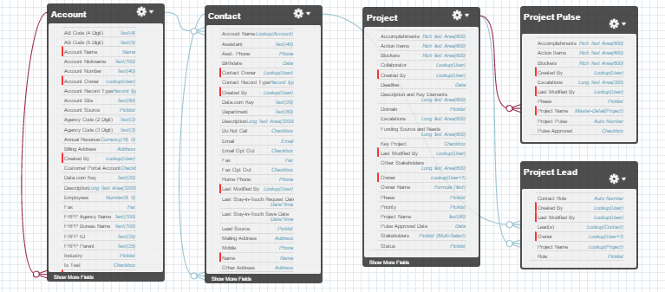

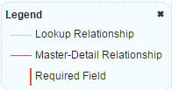

*Project Dashboard - Entity Relationship Diagram - Figure 1.0*

|  |
| --- |
| **3.3 HIGH LEVEL SYSTEM PROCESS FLOW** |

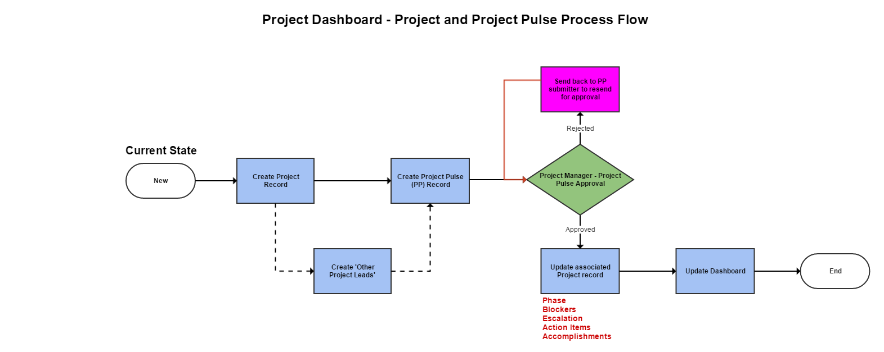

*Project Dashboard - High Level Process Flow*

# **4 - NEW FUNCTIONALITY**

|  |
| --- |
| **4.1 PROCESS AUTOMATION** |

*N/A*

|  |
| --- |
| **4.2 APPLICATION AND USER INTERFACE DESIGN** |

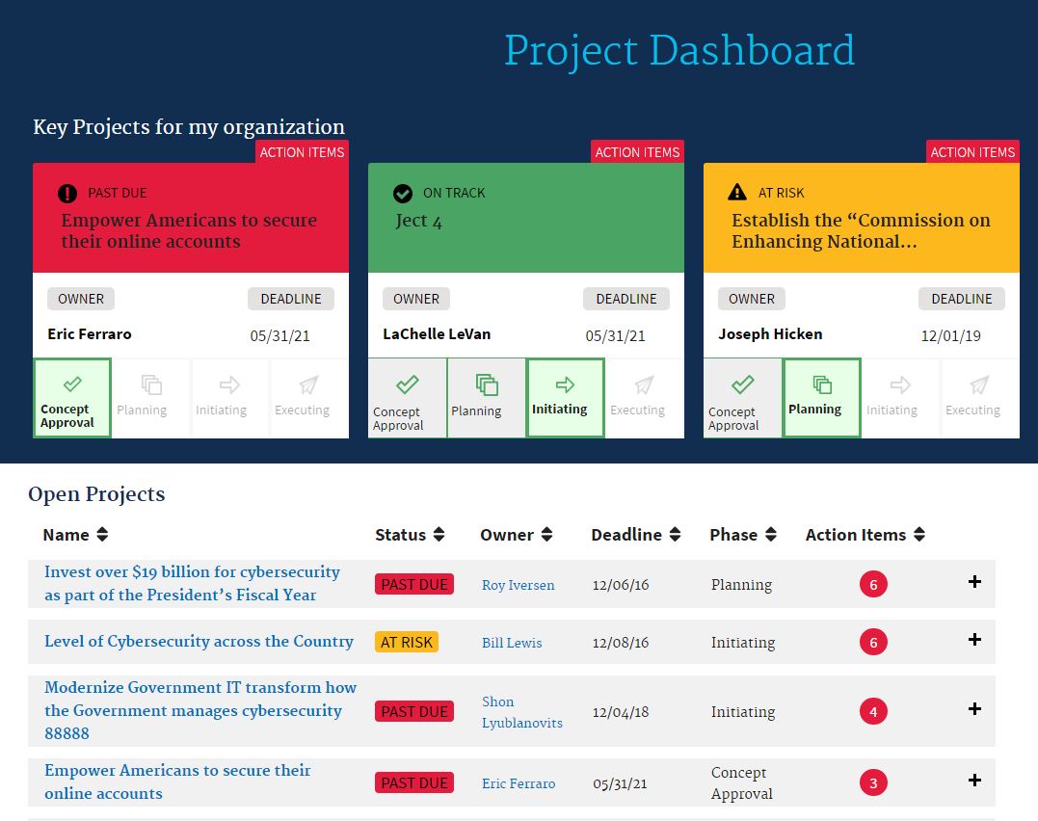

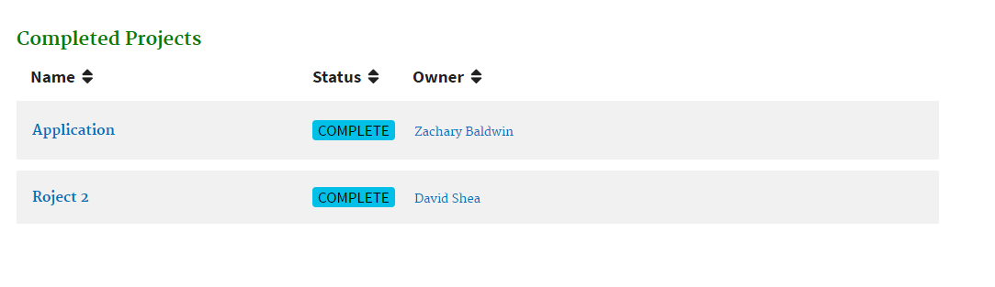

*Project Dashboard*

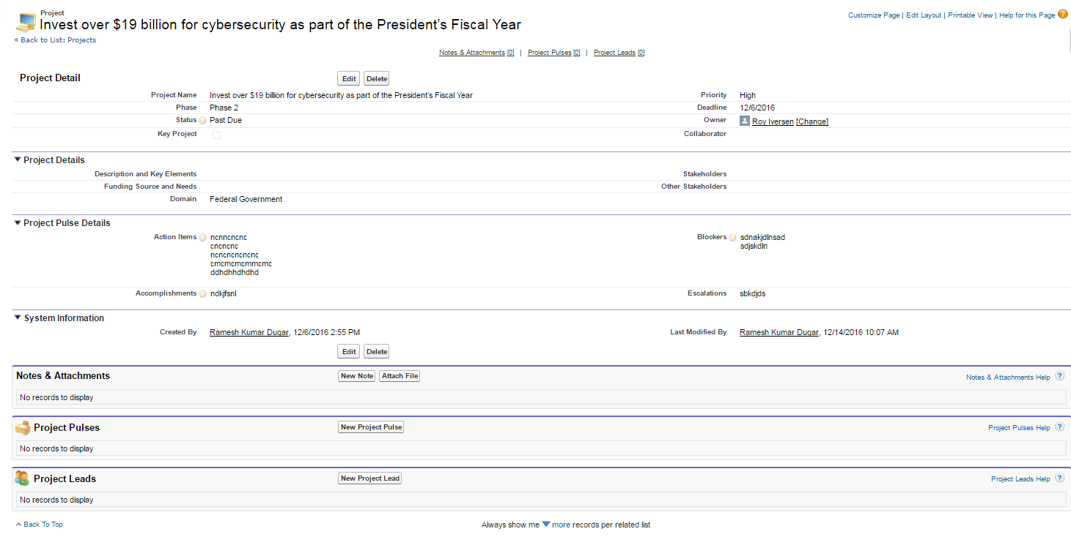

*Project Dashboard - Project Details Page*

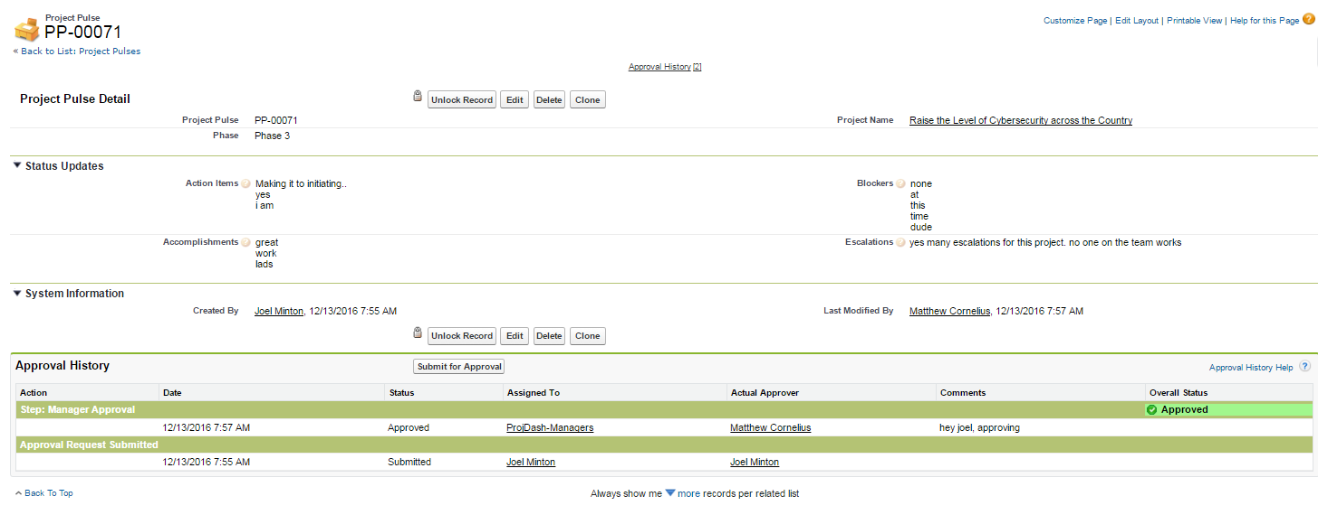

*Project Dashboard - Project Pulse Details Page*

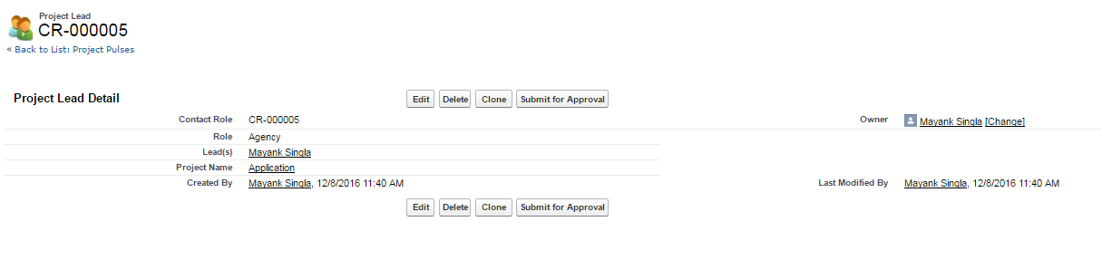

*Project Dashboard - Other Project Leads Detail Page*

|  |
| --- |
| **4.3 CONFIGURATION DETAILS** |

*Provide any details or impacts to the following areas as it applies to configuration of the solution:*

* **Tab Setup:**
  + Home, Projects, Project Pulses, Project Dashboard, Reports
* **App Setup:** Project Dashboard
* **User Profile Setup:**
  + No new profiles will be created for this application. Access can given via permission sets
* **Permission Set Setup:**
  + ProjDash - Manager - CRED
    - Assigned to Program Manager who will have Create, Read, Edit, Delete, and View All access to Projects. Read, Edit, Delete, and View All access will be given for the Project Pulse object. Read, Create, Edit, and Delete access will be given to the EOP/Agency Leads object.
  + ProjDash - Owner/Collaborator - CRED
    - Assigned to Project Managers, Owners, and Collaborators who will create, read, edit and delete Project Pulses. Read access will be given to the Project object.
* **Role Hierarchy Considerations:** Not Applicable
* **Workflows:**

|  |  |  |
| --- | --- | --- |
| **Rule Name** | **Description** | **Object** |
| ProjDash-Project-StatusUpdate | When the Status equals 'Complete', the Phase field value will update to 'Close-Out/Close' | Project |

* **Approval Processes:**

|  |  |  |
| --- | --- | --- |
| **Process Name** | **Description** | **Object** |
| ProjDash-ProjectPulseApproval | ProjDash - This approval process is submitted by the individual Project Manager to the Program Manager for approval on all project pulse records | Project Pulse |

* **Process Builder:**

|  |  |  |
| --- | --- | --- |
| **Process Name** | **Description** | **Object** |
| ProjDash-ProjectPulseApproval | ProjDash - This approval process is submitted by the individual Project Manager to the Program Manager for approval on all project pulse records | Project Pulse |

* **Reports & Dashboards:** *Not Applicable*
* **Validation Rules**: *Not Applicable*
* **Public Groups:**

|  |  |  |
| --- | --- | --- |
| **Label** | **Name** | **Use or Description** |
| ProjDash-Managers | ProjDash_Managers | This public group is for Program Managers to have CRED access over all Projects, Dashboards, Reports, and the ability to approve, read and edit all Project Pulse records |
| ProjDash-Owners | ProjDash_Owners | This public group is for Project Managers and Collaborators that are record owners of Projects and Project Pulse Records. |

* **Queues:**

|  |  |  |
| --- | --- | --- |
| **Queue Label** | **Queue Name** | **Use or Description** |
| ProjDash-Managers | ProjDash_Managers | This queue is used in the Project Pulse approval process. Members of this queue will be delegated as ‘Assigned Approvers’ for any submitted Project Pulse records |

* **Sharing Rules:** *Not Applicable*

|  |
| --- |
| **4.4 DATA SHARING MODEL** |

*Provide a written explanation of the proposed access control solution as well as any supporting diagrams illustrating the overall data sharing model for the functionality. This should include the existing roles and profiles leveraged as well as outline the justification for using new roles, profiles, permission sets, and groups.*

**Org-Wide Defaults:**

|  |  |  |
| --- | --- | --- |
| **Object** | **Default Internal Access** | **Default External Access** |
| Project | Public Read/Write | Public Read/Write |
| Project Pulse | Controlled by Parent | Controlled by Parent |
| Project Lead | Public Read/Write | Public Read/Write |

Users who have the Read permission on the above objects will be able to view the projects, project pulses and project leads added to the project records. In addition to these objects, you must configure sharing settings for the Contact, and perhaps, the Account objects in your org.

|  |
| --- |
| **4.5 CUSTOM DEVELOPMENT DETAILS** |

*Provide all details for any necessary custom development included in the solution.*

* **Force.com objects (Custom or Standard):**
* **Project (API Name: ProjDash_Project__c):**

Fields

|  |  |  |  |  |
| --- | --- | --- | --- | --- |
| **Field Label** | **API Name** | **Data Type** | **Controlling Field** | **Track History** |
| Project Name | Name | Text (80) |  |  |
| Accomplishments | Accomplishments__c | Rich Text Area(600) |  |  |
| Action Items | Action_Items__c | Rich Text Area(600) |  |  |
| Blockers | Blockers__c | Rich Text Area(600) |  |  |
| Collaborator | Collaborator__c | Lookup(User) |  |  |
| Deadline | Deadline__c | Date |  |  |
| Description and Key Elements | Description_and_Key_Elements__c | Long Text Area(600) |  |  |
| Domain | Domain__c | Picklist |  |  |
| Escalations | Escalations__c | Long Text Area(600) |  |  |
| Funding Source and Needs | Funding_Source_and_Needs__c | Long Text Area(600) |  |  |
| Key Project | Key_Project__c | Checkbox |  |  |
| Other Stakeholders | Other_Stakeholders__c | Long Text Area(600) |  |  |
| Owner Name | Owner_Name__c | Formula (Text) This formula references multiple objects |  |  |
| Phase | Phase__c | Picklist |  |  |
| Priority | Priority__c | Picklist |  |  |
| Pulse Approved Date | Pulse_Approved_Date__c | Date |  |  |
| Stakeholders | Stakeholders__c | Picklist (Multi-Select) |  |  |
| Status | Status__c | Picklist |  |  |

Custom Buttons

|  |  |  |  |
| --- | --- | --- | --- |
| **Label** | **Name** | **Type** | **Description** |
| Project Dashboard | ProjectDashboard | List Button | Javascript button on the Project object list view to take the user to the ProjectDashboard VF page on click |

* **Project Pulse (API Name: ProjDash_ProjectPulse__c):**

Fields

|  |  |  |  |  |
| --- | --- | --- | --- | --- |
| **Field Label** | **API Name** | **Data Type** | **Controlling Field** | **Track History** |
| Project Pulse | Name | Auto Number |  |  |
| Accomplishments | Accomplishments__c | Rich Text Area(600) |  |  |
| Action Items | Action_Items__c | Rich Text Area(600) |  |  |
| Blockers | Blockers__c | Rich Text Area(600) |  |  |
| Escalations | Escalations__c | Long Text Area(300) |  |  |
| Phase | Phase__c | **Picklist** |  |  |
| Project Name | Project_Name__c | Master-Detail(Project) |  |  |
| Pulse Approved | Pulse_Approved__c | Checkbox |  |  |

* **Project Lead (API Name: ProjDash_ProjectLead__c)**

Fields

|  |  |  |  |  |
| --- | --- | --- | --- | --- |
| **Field Label** | **API Name** | **Data Type** | **Controlling Field** | **Track History** |
| Contact Role | Name | Auto Number |  |  |
| Project Name | Project_Name__c | Lookup(Project) |  |  |
| Lead(s) | Lead_s__c | Lookup(Contact) |  |  |
| Role | Role__c | Picklist |  |  |

* **Contact:** *Not Applicable*

**NOTE:** You may need to customize the contact object depending on your org’s sharing model as Project Lead object has a lookup relationship with Contact object

* **Lead:** *Not Applicable*
* **Account:** *Not Applicable*
* **Opportunity:** *Not Applicable*
* **Field History:** *Not Applicable*
* **Custom Report Types:** *Not Applicable*
* **Chatter Enabled Objects:** *Not Applicable*
* **Visualforce Pages:**

|  |  |
| --- | --- |
| **Name** | **Description** |
| ProjectDashboard | Visualforce Page to display the Project Dashboard |

* **Triggers:** *Not Applicable*
* **Apex Code:**

|  |  |  |  |  |
| --- | --- | --- | --- | --- |
| **Name** | **API Version** | **Status** | **Description** | **Code Coverage** |
| ProjDash_Controller | 37.0 | Active | Controller Class for ProjectDashboard VF page | 100% |
| ProjDash_ControllerTest | 37.0 | Active | Test class for apex controller ProjDash_Controller |  |
| ProjDash_EmailReminderScheduler | 36.0 | Active | Scheduler class to send email to Project owners every Monday at 9:00am(time can be configured as needed) | 100% |
| ProjDash_EmailReminderTest | 36.0 | Active | Test class for ProjDash_EmailReminderScheduler |  |

* **Custom Labels:**

|  |  |
| --- | --- |
| **Name** | **Value** |
| ProjDash_KeyProjects_Title | Key Projects for My Organization |
| ProjDash_NokeyProjErrorMessage | No Key Projects selected |
| ProjDash_PageTitle | Project Dashboard |
| ProjDash_Status_four | On Track |
| ProjDash_Status_one | At Risk |
| ProjDash_Status_three | Complete |
| ProjDash_Status_two | Past Due |
| ProjDash_Tracker_Phase1 | Phase 1 |
| ProjDash_Tracker_Phase2 | Phase 2 |
| ProjDash_Tracker_Phase3 | Phase 3 |
| ProjDash_Tracker_Phase4 | Phase 4 |
| ProjDash_Tracker_Phase5 | Close-Out/Close |

* **Force.com sites:** *Not Applicable*
* **Javascript:** *Yes*
* **jQuery** *: Yes*
* **Web Service/API Code:** *Not Applicable*
* **Customer Portals:** *Not Applicable*
* **Communities:** *Not Applicable*
* **Site.com:** *Not Applicable*
* **Third Party Applications:** *Not Applicable*
* **Static Resources**:
  + ProjectDashboardCSS
  + ProjectDashboard - Static Resource for all icons for Project Dashboard
* **Other:** *Not Applicable*

|  |
| --- |
| **4.6 SYSTEM INTEGRATION/INTERFACE** |

*Provide a technical architecture of the solution as applicable. Also, please detail all integration/interface considerations of the solution and also provide answers to the following questions:*

* Will the proposed solution provide source information to other systems?:
* What information is needed as an input, and from what system?:
* What information will be provided to what systems as an output? *Please note that Cast Iron is the preferred integration tool for GSA Salesforce integrations and should be supported in considering your outputs*:

|  |
| --- |
| **4.7 DATA MANAGEMENT** |

*Provide all impacts to Data Management as applicable instances might include data migration, data uploads, manual data operations (one time or regular). Please also provide a description of data quality on initial load if applicable.*

All data will be initially entered manually by the business as there are only 15 Projects at this time.

|  |
| --- |
| **4.8 SELF-ASSESSMENT** |

*Please take the security self-assessment. Please use this section to paste all the identified vulnerabilities produced after you complete the assessment and provide answers to each one listed as to how the design will mitigate the vulnerability:* [*http://security.force.com/security/tools/forcecom/assessment*](http://security.force.com/security/tools/forcecom/assessment)

# **5 - CONSIDERATIONS**

**Format: *CONSIDERATION:*** *Explanation*

|  |
| --- |
| **ADDENDUM** |